**API Documentation simple-api**

Request **:**

|  |  |  |  |
| --- | --- | --- | --- |
| **Parameter** | **Desc** | **Type** | **Example Value** |
| pagination | Page Search | Int | 1 |
| searchword | Tittle of Movie | String | Bat |

Response **:**

|  |  |  |  |
| --- | --- | --- | --- |
| **Parameter** | **Desc** | **Type** | **Example Value** |
| trxid | Transaction id of proses | String | 20210815090629 |
| error_code | Error code of proese | String | 0 |
| error_message | Error message of proses | String | success |
| list | Object of Movie | []Movie |  |

Movie

|  |  |  |  |
| --- | --- | --- | --- |
| **Parameter** | **Desc** | **Type** | **Example Value** |
| tittle | Tittle of Movie | String | Batman |
| Year | Year of Movie | String | 1993 |
| imdbID | imdbID of Movie | String | tt0105655 |
| Type | Type of Movie | String | movie |
| Poster | Poster of Movie | String | url |

**Test GRPC**

Valid Flow

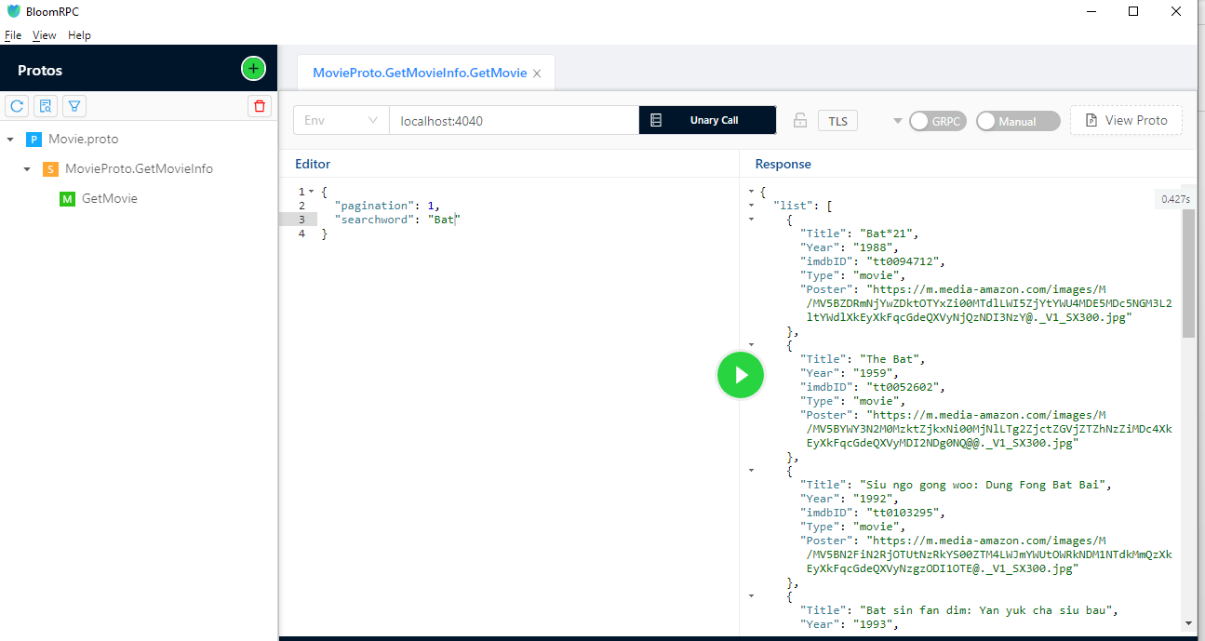

|  |  |
| --- | --- |
| Request : | Response : |

Invalid Flow (invalid pagination value)

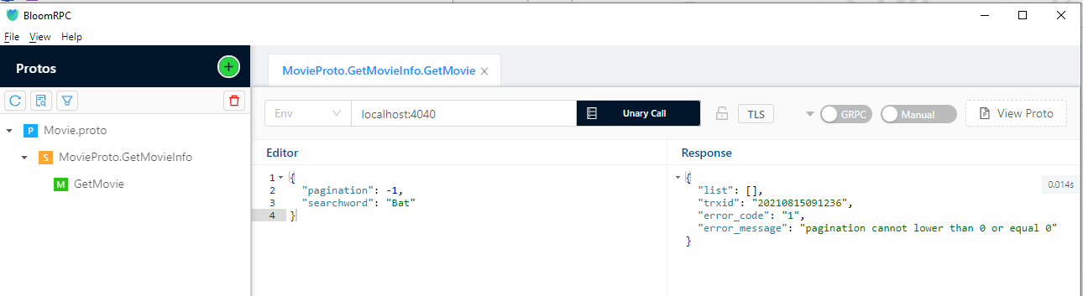

|  |  |
| --- | --- |
| Request : | Response : |

Invalid Flow (invalid tittle value)



|  |  |
| --- | --- |
| Request : | Response : |

**Test via PostMan Rest**

Valid Flow

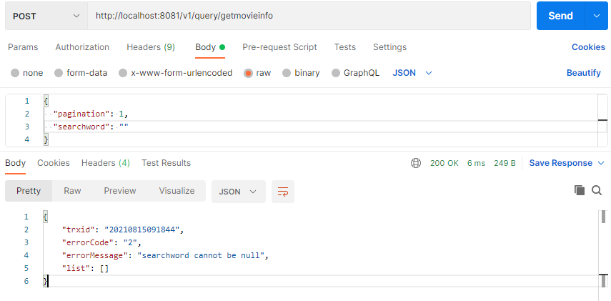

|  |  |
| --- | --- |
| Request : | Response : |

Invalid Flow (invalid pagination value)

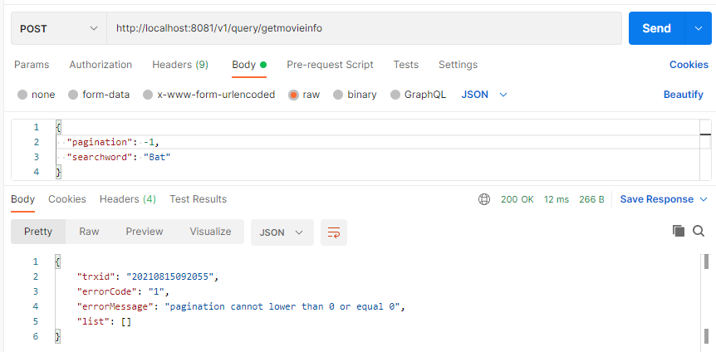

|  |  |
| --- | --- |
| Request : | Response : |

Invalid Flow (invalid tittle value)

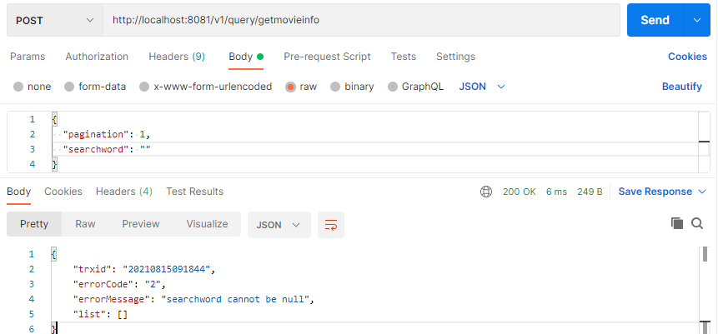

|  |  |
| --- | --- |
| Request : | Response : |